Tshwane Masters Committee contact details for the 2012-2013 season
TSHWANE MASTERS COMMITTEE

PO. Box 14389
Lyttelton 0140 South Africa

President | Name: | Craig Stanton
 | Email: | craigren@global.co.za
 | Cell no: | 082 823 2640
Vice-President | Name: | Anton Harrop-Allin | 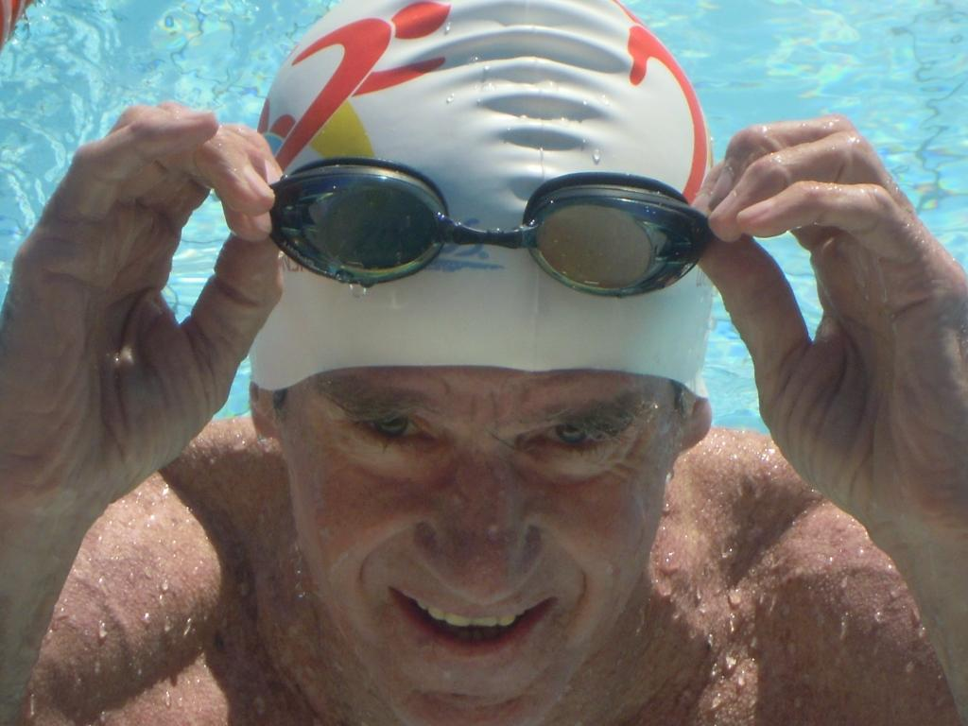
 | Email: | antonha@fence-steel.com
 | Cell no: | 082 490 3740
Secretary | Name: | Rita Burger
 | Email: | ritaribbensburger@gmail.com
 | Cell no: | 082 782 6468
Treasurer | Name: | Dave Arbuthnot
 | Email: | davidericarbuthnot@yahoo.com
 | Cell no: | 082 395 3546
Registrations | Name: | Derek Fyfe
 | Email: | fyfe@lantic.net
 | Cell no: | 072 638 5855
Functions | Name: | Liz Ledbitter
 | Email: | lizledbi@telkomsa.net
 | Cell no: | 082 362 2605
Coelacanth Rep | Name: | Terry Downes
 | Email: | downet@health.gov.za
 | Cell no: | 082 880 5340
Old School  Masters Rep | Name: | Erna Hattingh
 | Email: | ernah@geoscience.org.za
 | Cell no: | 082 445 5620

