Region / Club Committee contact details for the 2011-2012 season
Free State Masters Swimming Club
  
P O Box 43392 Heuwelsig 9332
President | Name: | Danie Schoeman | 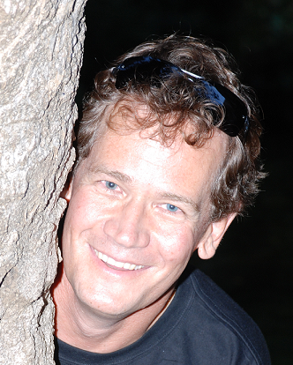
President | Email: | danie.schoeman@mangaung.co.za
President | Cell no: | 082 856 2741
President | Home no: | 051 436 0151
Vice-President | Name: | Amelia Scott | >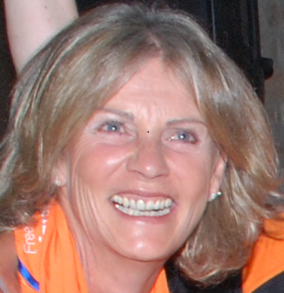
Vice-President | Email: | info@ridges.co.za
Vice-President | Cell no: | 082 558 8258
Vice-President | Home no: | 011 465 5354
Secretary | Name: | Barbara Hickling | 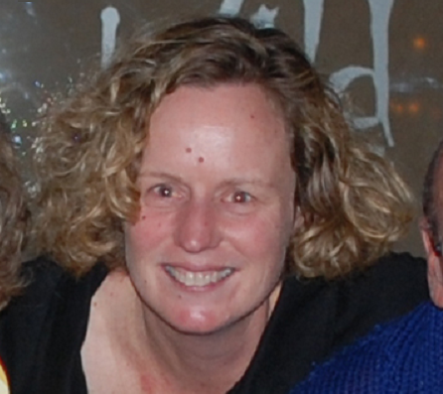
Secretary | Email: | ptc@lantic.net
Secretary | Cell no: | 082 900 5698
Secretary | Home no: | 051 436 5440
Treasurer | Name: | Barbara Hickling
Treasurer | Email: | ptc@lantic.net
Treasurer | Cell no: | 082 900 5698
Treasurer | Home no: | 051 436 5440
Registration Sec. | Name: |  | <insert thumbnail picture here>
Registration Sec. | Email: |  | <insert thumbnail picture here>
Registration Sec. | Cell no: |  | <insert thumbnail picture here>
Registration Sec. | Home no: |  | <insert thumbnail picture here>
Gala Sec. | Name: |  | <insert thumbnail picture here>
Gala Sec. | Email: |  | <insert thumbnail picture here>
Gala Sec. | Cell no: |  | <insert thumbnail picture here>
Gala Sec. | Home no: |  | <insert thumbnail picture here>
Additional | Name: | Dawn Rottanburg | 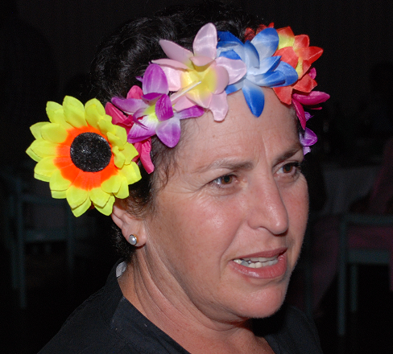
Additional | Email: | dawn.rottanburg@lifehealthcare.co.za
Additional | Cell no: | 083 324 3358
Additional | Home no: | 018 468 0039
<other portfolio> | Name: |  | <insert thumbnail picture here>
<other portfolio> | Email: |  | <insert thumbnail picture here>
<other portfolio> | Cell no: |  | <insert thumbnail picture here>
<other portfolio> | Home no: |  | <insert thumbnail picture here>

